**An AI-Powered Medical Assistance App**

Aarithi Rajendren

ENC3246

**Abstract**

Keeping track of one’s health is essential to the detection and prevention of major illnesses and reducing the severity of illnesses through medicine. Having an app that enables users to access their health information, contact a healthcare professional, and access to reliable information regarding illnesses all through a mobile phone can prove to be extremely beneficial to students at the University of Florida (UF). Students who reside on and off campus often cannot find the time or the means to travel to the healthcare services at UF, which inadvertently results in the student’s health not being a priority. This paper discusses the benefits of having an AI-powered medical assistance app and the concerns students have regarding a digital app supported by AI. The data analyzed was obtained through a survey and following this analysis, there is a discussion about what an AI-powered medical assistance app should address to ensure maximum success with UF students.

**Introduction**

Healthcare is a necessity for everyone, especially college students as they navigate through living alone for the first time in a new environment. Thus, students need easy to access physical and mental health resources to ensure they can stay healthy to cope with their academic, social, and other pressures they face on a day-to-day basis. Often, students find it hard to find the means to travel to a clinic or cannot find the time to seek out a healthcare professional. Thus, the use of Artificial Intelligence (AI) to create medical assistance apps that are easily accessible to all students through their phones, provides a more convenient option for students to receive timely and appropriate healthcare.

*Related Literature:* There has been an increase in awareness of the shortcomings presented in a traditional clinical setting. One of these shortcomings is patients being unable to obtain timely medical advice due to long wait times for an appointment [1]. Healthcare resources are often far and few in between especially in rural areas, which leads to people in those areas not obtaining medical advice in an effective manner [1]. This leads to people receiving better healthcare solely based on their geographic location.

Another application of AI is the ability to have electronic medical records where specific algorithms can be used to identify subjects with a family history of a hereditary disease or an increased risk of a chronic disease [2]. This application of AI enables patients to view any updates immediately through an app or website.

Furthermore, an interesting technology that has been recently developed is called Aria, which was released by SK Telecom of South Korea and is a smart voice-activated device made possible by AI [3]. This device can make emergency calls when a person cannot use other devices because of accidents, physical handicaps, or unique situations [3]. This hands-off technology has been extremely useful in saving elderly people who live alone [3]. In addition, AI can play a crucial role in improving certain aspects of healthcare to become more efficient. According to Forbes, the most beneficial aspects of AI for healthcare purposes would be administrative workflows, image analysis, robotic surgery, virtual assistants, and clinical decision support [4].

Therefore, AI has been proven to play a critical role in improving people’s healthcare accessibility and can be implemented in the form of a digital medical app for college students to improve their access to healthcare as well.

The purpose of our study is to investigate whether students’ health would be improved by using an AI powered medical assistance application to meet their healthcare needs and what features they would expect to see in such an application. This application would drastically improve accessibility for students since they can view health information and be in touch with a healthcare professional all through a few taps on their phones. We need to know whether students would be willing to use an AI powered healthcare application and how widely useful this application would be to determine whether this application should be created.

The research question we will be basing our study around is “how can we best apply AI to healthcare so that college students, specifically from UF, receive improved care?”.

**Methods**

Our team had decided to use a survey as our method for data collection. The goal of this survey was to determine if UF students would benefit from having a healthcare app and how they would feel about this app being powered by AI. To ensure our app would have a wide range of success we had to gauge whether students were hesitant to use technology supported by AI and if they currently feel as though they have difficulties accessing healthcare resources. Thus, for the purpose of our study, a survey was the most efficient way to collect data from students.

*Materials*: The survey was created through Qualtrics, which is a service for creating and delivering web-based surveys for academic research. Qualtrics automatically creates reports of the responses received from the survey, which are easy to access and allow for an in-depth analysis of the data. Also, it is a website that most UF students are familiar with and have used at some point.

*Procedure:* At first, each group member wrote 2 questions on a google doc and then we collaborated and picked the 7 most appropriate questions. Then we created the survey on Qualtrics using the 7 questions we agreed upon. After the survey was created, each group member sent out the survey through their social media platforms, which included iMessages, Instagram, and GroupMe. The form was open for responses for 24 hours from March 25th to March 26th. Once the form closed, we created the reports available on Qualtrics for the 64 responses we received.

*Survey:* Our study’s target population was UF students regardless of whether they lived on or off campus. The survey asked students about their experiences with healthcare services at UF, their thoughts on an AI powered medical app, and what features they would like to see on the app. The last question was an open-ended question, that encouraged participants to be detailed about any barriers they have faced when accessing healthcare services.

**Results**

Our results displayed that about 33% of students have never sought healthcare services at UF and 34% of students were only somewhat satisfied with their healthcare experiences at UF (Figure 1).

Figure 1: Student satisfaction with the healthcare services at UF.

The survey showed that 26% of students would be neutral about receiving healthcare suggestions from an AI powered medical assistance app and about 32% of students would be either somewhat opposed or extremely opposed (Figure 2). Also, 65% of students were either somewhat concerned or extremely concerned about the privacy and security of their information when using a digital app (Figure 3).

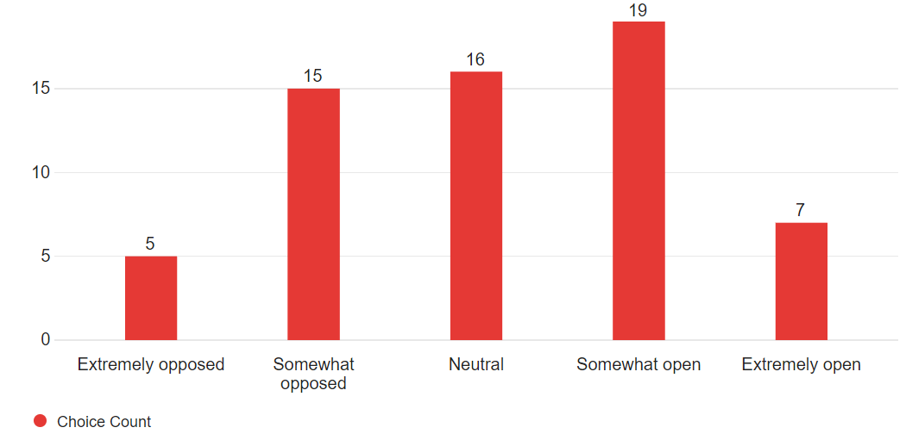

Figure 2: Openness of students to receiving healthcare suggestion from an AI powered medical assistance app.

Figure 3: Level of concern student's face regarding privacy and security when using a digital health app.

The study found that 65% of students were either somewhat likely or extremely likely to use a mobile app for medical care support (Figure 4).

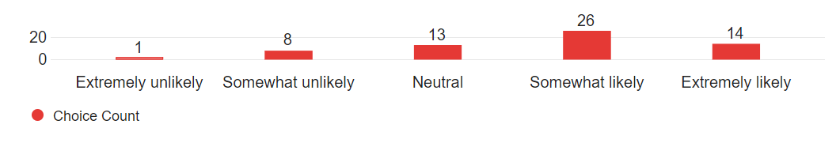

Figure 4: Likelihood of students using a mobile app for medical support.

As seen in Figure 5, 27% of students are neutral to receiving mental health support from a mobile app and 42% of students are either somewhat unlikely or extremely unlikely to use an app for such purposes (Figure 5).

Figure 5: Likelihood of students using a mobile app for mental health support.

Figure 6 portrays the distribution of which features students would find most beneficial in a healthcare app. Only 31% of students found the mental health support feature to be beneficial while every other feature had over 65% of students selecting it as beneficial (Figure 6).

Figure 6: Features students find most beneficial in a healthcare app.

**Discussion**

It is clear from Figure 1 that the healthcare services offered at UF are not sufficient for students. The 33% of students who have not sought healthcare services at UF from Figure 1 can be attributed to them not needing any healthcare assistance or that the services were not accessible when they were required. Furthermore, the 34% of students that were only somewhat satisfied with the healthcare services at UF suggests that those students are unlikely to seek out those services again, even when it might be necessary. Also, only 4% of students were extremely satisfied with their healthcare experience, which is an extremely low satisfaction rate. This is concerning since college students’ risk some of the highest numbers of life lost from illnesses and injuries that are largely preventable; thus, it is crucial that these students are satisfied with their healthcare experiences to ensure they feel comfortable to seek medical help whenever necessary [5].

Figures 2 and 5 display the reluctance and hesitance students face when it comes to AI and using technology for their healthcare needs. An overwhelming 65% of students are concerned about the privacy and security of their information when using a digital app as well as 32% students were either somewhat or extremely opposed to using an AI powered medical assistance app. In a similar study done by Baldauf and his team, participants explicitly emphasized the importance of protecting users’ health data where they mentioned the need for strong encryption and authentication [6]. Along with this their study also revealed three relevant trust factors for users’ trust in AI-driven self-diagnosis apps: an official medical certification, the guarantee of anonymized transmission and analysis of the users’ personal health data, and a trustworthy app publisher [6]. Thus, for our app to be well received by UF students, we would need to ensure that we can guarantee the protection of their data.

Furthermore, Figure 6 displays that there are some key features that students would find beneficial in a healthcare app. Although the mental health support feature was voted as the least beneficial, this may be due to the stigma around mental health and the hesitation students may feel when admitting that they need help as seen in Figure 5. Therefore, our app would have to ensure that any communication with a healthcare professional or reports regarding their mental health would be completely confidential and the feature is simply there to use at their discretion.

**Conclusion**

An analysis of the data collected revealed that UF students’ healthcare would benefit from having an AI-powered medical assistance app on their mobile phones. However, students have concerns regarding the privacy and security of their information, which would have to be addressed before students feel safe to use the app. The feedback also suggests that there are some features such as fitness and wellness tracking and medication reminders that students would find beneficial, so ensuring the app has these features would ensure students feel like their healthcare needs are being met. We now have sufficient information that our proposal for a healthcare app supported by AI would appeal to UF students if we can guarantee protection of user information.

**References**

[1] X. Fan et al., “Utilization of Self-Diagnosis Health Chatbots in Real-World Settings: Case Study”, *Journal of Medical Internet Research*, vol. 23, pp. 1-16, 2021.

[2] Pavel Hamlet, Johanne Tremblay, “Artificial intelligence in medicine”, Metabolism, vol. 69, pp. 36-40, 2017.

[3] Lee, D. and Yoon, S.N., (2021). Application of artificial intelligence-based technologies in the healthcare industry: Opportunities and challenges. *International journal of environmental research and public health*, *18*.

[4] A. Bohr and K. Memarzadeh. “The rise of artificial intelligence in healthcare applications.” *Artificial Intelligence in Healthcare,* pp. 25–60, 26 Jun. 2020.

[5] T. W. Grace, “Health Care Problems of College Students”, *Journal Of American College Health,* vol. 45, pp. 245-251, Jul. 2010.

[6] M. Baldauf, P. Fröhlich, R. Endl, “Trust Me, I’m a Doctor – User Perception of AI-Driven Apps for Mobile Health Diagnosis”, *Association for Computing Machinery*, pp. 167-178, 2020.